BODHI BLUEPRINT PROGRAM

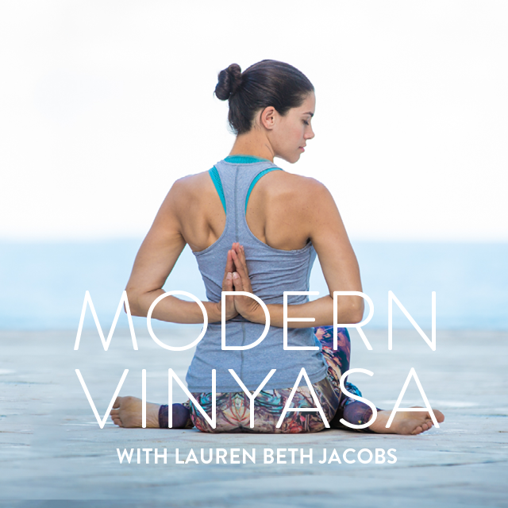

WEEK 5: GET GROUNDED

Week 5: Get Grounded (Solidifying New Habits)

“This being human is a guest house. Everyday a new arrival. A depression, a joy, a meanness some momentary awareness comes as an unexpected visitor. Welcome and entertain them in! The dark thought, the shame, the malice, meet them at the door laughing and invite them in. Be grateful for whoever comes, because each has been sent as a guide beyond.’’ - Rumi

Week 5 Requirements
- Movement - 5 sessions/week with 1-2 being home practices of 45 + minutes.
- Meditation – 3-25 minutes/day everyday
  - Try a “moving meditation”
- Nutrition - Grounding/High-Mineral Foods
  - This week begin to incorporate grounding/high-mineral foods back into your diet.
- Self-Inquiry - Power of Declaration.

Nutrition Reflection Questions
- What good habits were you able to maintain after the cleanse was over? How does that make you feel both physically and emotionally?
- What “bad” habits did you pick back up? How does that make you feel both physically and emotionally?

Breaking Free and Setting New Ways: Power of Declaration
- Reauthor your own perspective about yourself (in holding your vision):
- From pure space, I give up the lie that I am______
- From pure space, I give up the lie that I am not____
- My new way of being is________ (list three intentions/affirmations)

General Support Questions
- When, where and with whom do I feel the most grounded? What my friends? myself? with my spouse/partner?
- When do I feel ‘in flow’?
- When do I feel most energized?

Affirmations
- Recite your ‘New Way of Being’ before you go to bed and upon rising in the morning every day.

