BODHI BLUEPRINT PROGRAM

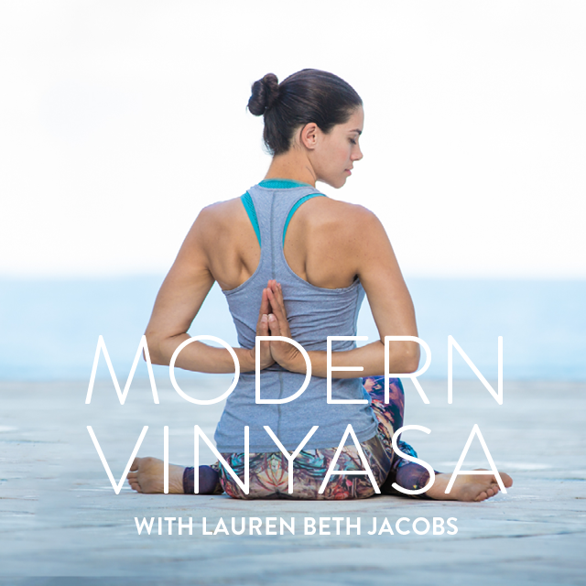

WEEK 1: GET PRESENT

Week 1: Get Present (Identifying Your Current Habits)

‘To practice is to pay attention to your whole life, your thoughts, bodily sensations, speech, actions. Each moment of your life is a moment of practice.’

Week 1 Requirements
- Movement – Exercise 4-5 days this week for at least 30 minutes each session. Brisk walks count.
- Meditation – 3-5 minutes/day everyday and journal as needed.
- Nutrition - Awareness
o Introduce Food Journaling: Identify what foods you are eating. Start to bring awareness around your eating patterns and habits.
• Self-Inquiry - Identifying Where You Are NOW.

Week 1: Get Present

Nutrition Reflection Questions
- What are you eating for B/L/D?
- Do you (mostly) cook or eat out?
- Do you sit down or eat on the go?
- Do you chew your meals thoroughly and mindfully?
- How much of the following do you consume: coffee, alcohol, gluten, animal products, processed foods and sugar?
- Did you take any supplements?
- What positive or happy thoughts do you have daily?
- Do you laugh out loud or tell someone that you love them daily?
- Do you spend time outside in nature, even for 5 minutes?
- Do you get eight hours of sleep?
- How is your elimination?
- What time do you stop eating?
- How do you feel physically?
- How do you feel emotionally?

Breaking Free and Setting New Ways: Identifying where you are NOW
- When and where am I in my comfort zone?
  - How often do I live there?
  - How do I feel when I am there?
- What am I resisting? And how will I let go?

General Support Questions
- What do I think about: my body? relationships? work? spirituality? money?
- When in my life am I fully present?
- Where in my life am I hiding?

